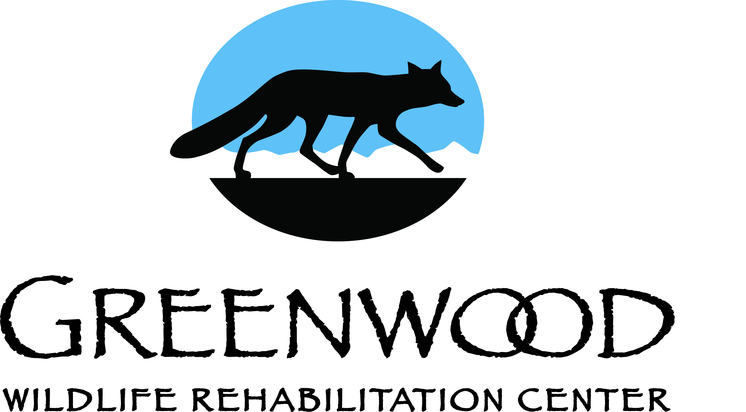
Greenwood Wildlife Rehabilitation
Animal Sponsorship Form

Date: ____________

Please select the type of animal you would like to sponsor. You will receive a laminated keepsake photo with a story about the animal.
Animal:
___ Songbird (Robins, Jays, Woodpeckers) - $40
___ Small Mammals (Squirrels, Cottontails, Chipmunks) - $60
___ Waterfowl/Shorebirds (Ducks, Geese) - $80
___ Raccoons - $100
___ Medium-sized Mammals (Foxes, Coyotes) - $150

Contact Information:

First Name: ___________________________ MI ____ Last Name: _____________________________

Street Address: ____________________________________ E-mail: _____________________________

City: __________________________________ State: ______________ Zip: ______________________

Phone #: __________________________________ Alt. Phone #: _______________________________
Information is for internal use only

Payment Information:

___ Credit Card type (Visa/M/C/AmEx)
Number _________________________________ Expiration Date (MM/YY) __________
Signature _______________________________________CCV # ___________________

___ Check (Make check payable to Greenwood Wildlife Rehabilitation Center)

To secure a sponsorship, please complete this form and return to:
Greenwood Wildlife Rehabilitation Center
Attn: Animal Sponsorship
P.O. Box 18987
Boulder, CO 80308
303-823-8455
or email mysti@greenwoodwildlife.org

___ In Honor of ___ In Memory of

Name and address of recipient whom Greenwood should notify of your gift:
______________________________________________________________________________
______________________________________________________________________________

If this is a gift - add a message: (example: Happy birthday! Love, Grandma Jones)
______________________________________________________________________________

