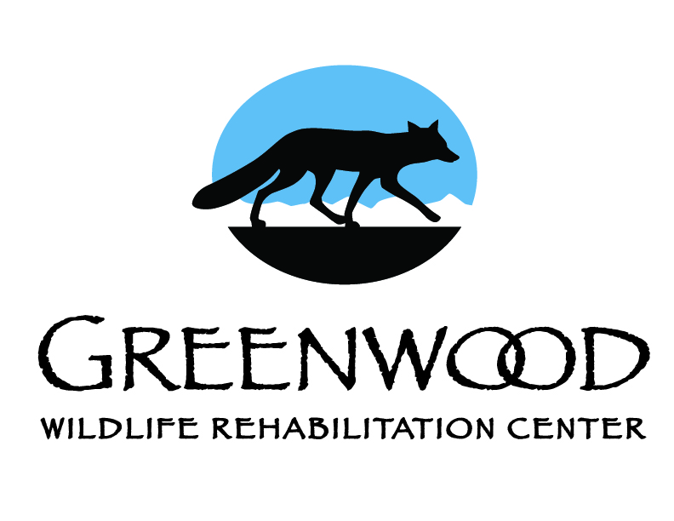
Date: _______________

INTERNSHIP APPLICATION

GREENWOOD WILDLIFE REHABILITATION CENTER

Please submit application by email to: interns@greenwoodwildlife.org

You may also mail it to:
Greenwood Wildlife
Attn: Internship Coordinator
PO Box 18987
Boulder, CO 80308

All applicants must be 18 or older. All applicants must have a valid driver’s license and reliable transportation. Internship positions run from March to October. Interns must dedicate 24-40 hours/week, working shifts on three or more days each week, for a minimum of eight weeks.

Please check the box for the internship session(s) that you are applying for:

Internship Sessions (pre-exposure rabies vaccines required to work with raccoons)

Spring Session 1: mid-March – mid-May

Spring Session 2: mid-April – mid-June

Summer Session 1: mid-May – mid-July

Summer Session 2: early June – early August

Summer Session 3: early July – late August

Fall Session: mid-August – mid-October

------------------------------------------------------------------------------------------------------------------------

Name: _________________________________________________ DOB:__________________

Address: ________________________________________________________________________

Home telephone: _______________________ Cell:______________________

Email address:______________________________________________________

Emergency Contact 1 Name/Phone: ____________________________________________________

Emergency Contact 2 Name/Phone: ____________________________________________________

How did you hear about Greenwood’s Internship Program?
____________________________________________________

References: Please do not include relatives.

Reference Phone |  | Reference Phone
Street Address City State Zip |  | Street Address City State Zip
Email | Job Title | Email | Job Title
How Acquainted and For How Long |  | How Acquainted and For How Long

WORK EXPERIENCE: List your previous experience, beginning with your current or most recent position. OK to attach extra pages or resume if necessary.

Employer | Starting Position
Street Address City State Zip | Most Recent Position
Supervisor Name/Title Phone | Start Date | End Date
Duties |  | # Hours/week
Reason for Leaving

Employer | Starting Position
Street Address City State Zip | Most Recent Position
Supervisor Name/Title Phone | Start Date | End Date
Duties |  | # Hours/week
Reason for Leaving

May we contact your current employer? Yes No
Are you legally authorized to work in the United States? Yes No

Please describe experiences (work, volunteer, internship, hobbies, etc.) that you think would help you as a Greenwood Intern.

Education & Training: Please include name, street, city, state and zip code for each school (include college, high school, and additional training).

School | City/State | # years completed | Degree(s) completed | Type of Course/Major

Additional Questions:

Why do you want to be an intern at Greenwood?

Please describe any previous animal experience that you have had:

What has been your favorite past job or volunteer experience, and what did you like about it?

At Greenwood we understand that everyone has occasional emergencies and illnesses, but it is critical for us to have reliable Interns who will commit to all of their shifts. Ability to work weekend and evening shifts is required. Do you think our policies in this area will be a problem for you? Do you have any plans for trips/vacations during your eight-week intern session?

Applicant’s Statement:
All of the information I have supplied in this application is a true and complete statement of the facts; if accepted as an Intern at Greenwood, any false statements or omission could result in immediate dismissal. I authorize you to contact all of my previous employers or references for full information regarding my employment history.

Signature Date

